**Quick Sort**

**Algorithm**

**Quick-Sort (A, p, r)**

if p < r then

q Partition (A, p, r)

Quick-Sort (A, p, q)

Quick-Sort (A, q + r, r)

**Partition (A, p, r)**

x ← A[p]

i ← p-1

j ← r+1

while TRUE do

Repeat j ← j - 1

until A[j] ≤ x

Repeat i← i+1

until A[i] ≥ x

if i < j then

exchange A[i] ↔ A[j]

else

return j

**Worst Case**

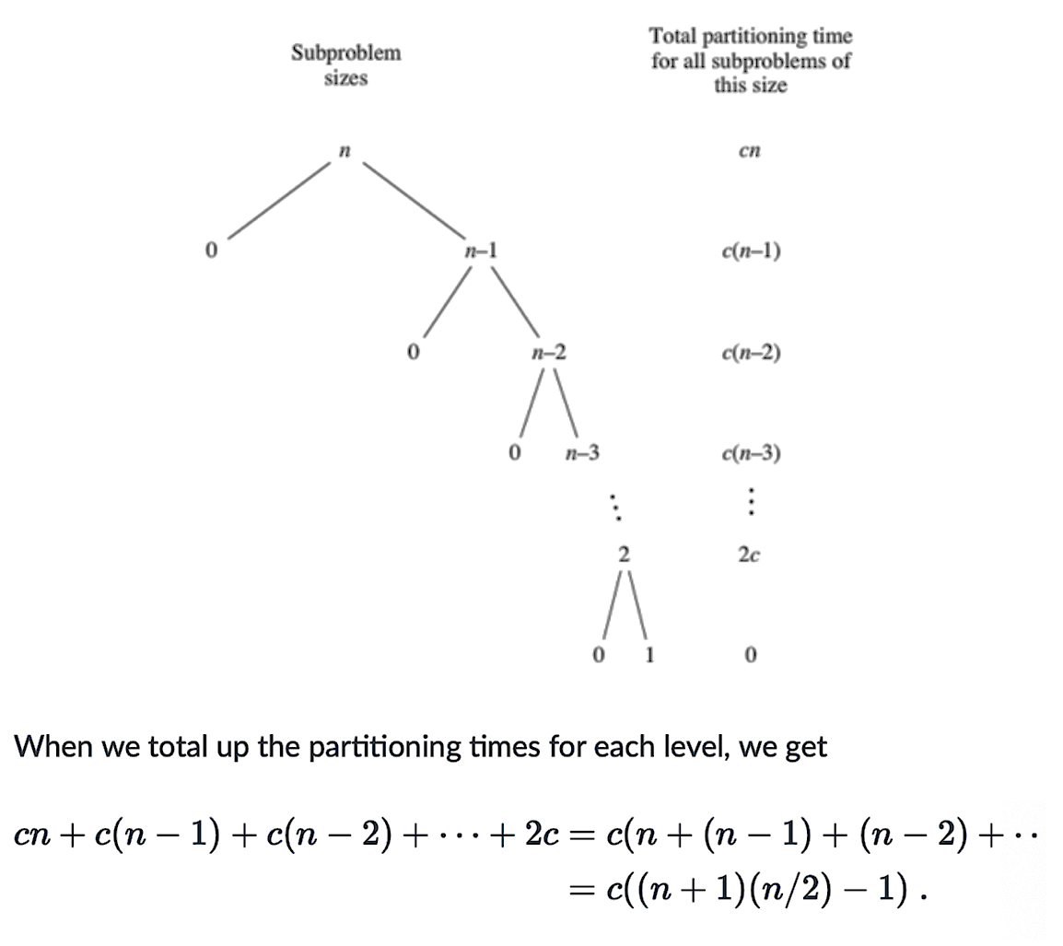

=  Θ(n2).

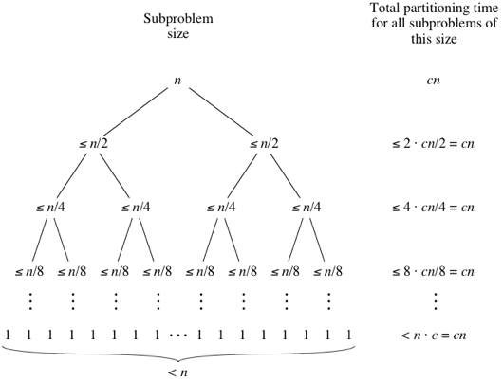**Best Case/Average Case**

Using big-Θ notation, we get the same result as for merge sort: Θ(nlog2n).